Tenda AC10-how to set Bandwidth Control?
Model Number: Tenda AC10
Question Classification: Function Setting

Step 1: Open a browser and type http://tendawifi.com in Address Bar, tap “Enter”. Enter login password and tap “Login”.

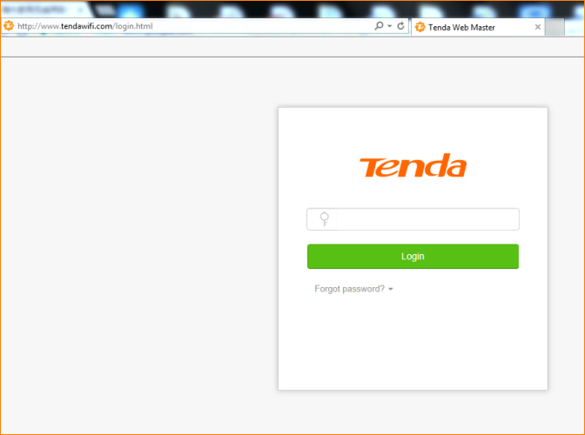
Step 2: Tap “Advanced Settings”, select “Bandwidth Control”

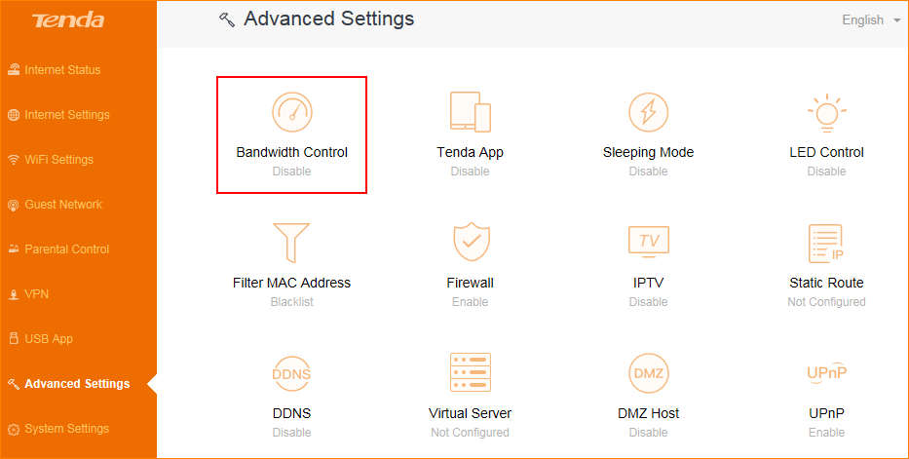

According to the bandwidth and your need, select the device that you want to control, then set the upload speed and download speed.

